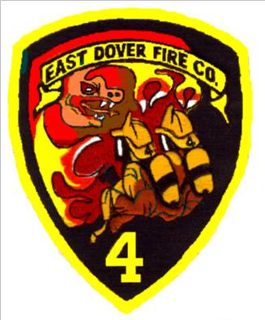

Dear Sponsor,

On May 19th, 2022 the East Dover Volunteer Fire Company #4 will hold its 25th Annual Golf Outing. Once again, this year we expect to have over 120 golfers and are already half way to selling out. This event is a major fundraiser for the fire company to help offset the everyday costs of running the firehouse.
This year’s event will also be a four-person scramble and will feature many interesting opportunities for golfers. There will be prizes for the winning teams, as well as hole prizes. There will be three opportunities for hole-in-one prizes, a chance to win a cash prize in a longest drive contest, and prize drawings.
The purpose of this letter is to offer you an extraordinary advertising proposal. For only $100.00 you can sponsor a tee box or a green at the outing and for $200.00 you can sponsor a golf cart.
You will be receiving great exposure as well as helping support volunteer firefighters in their fundraising efforts. If you are interested please fill out the application below and mail it to us:

East Dover Fire Company #4
629 Fischer Blvd.
Toms River, NJ 08753
Attn: Golf Outing

Or you can fax your reservation to us at (732) 270-2162,

Please contact: Kyle Reid (732) 267-7313 or kreid@trfire.org
Alex Linares (732) 216-8500 or alinares@trfire.org

Thank you in advance for your participation and support.

Member_______________________

Name: _______________________ Business: ___________________________________

Address: ___________________________________ Phone: ____________________

City: ___________________________ State: ______ Zip: _________________

Name to appear at hole: __________________________________________________

